Bruno Casas Pescador - Game Design Document

Section V - Interface

Visual System

HUD - What Controls

In the HUD we will find two main important features, the timer and the power bar, the timer is easy enough to understand, at the start of each level you are given a certain amount of time to complete the objective, to increase the time the player will slap people. if it goes below a threshold the music will slow down and the screen will go dimmer until it eventually goes dark, making it difficult to see how much time the player has or how much power has he obtained.

The power up bar will be located just below the timer at the top left corner, where also will be located a portrait of the main character in the attire of the level (or if the power icon or not.).

*Here we can see the how the in game HUD.*

Menus

There will be a total of— menus. The first one will be the main menu where the player must click “esc” or the top right button in the in game HUD to access. This menu will pause the game and appear in the middle of the screen as a list with the following options;

1. Options - here the player will be able to edit option such as; master volume, music volume, speech volume etc... (Discuss in group)
2. Restart level - This option is self-explanatory, if the player decides to reset the level he will just have to access here and it should restart it.
3. Restart game - Also self-explanatory, if the player wants to restart the whole game this is where he would have to click. This button however prompts a menu asking if the player is sure about the decision he is about to take.
4. Exit to windows - This will shut down the game, as the last one, it will prompt another menu asking the player for confirmation before doing such action as it may be unintended.

*Main menu*

Control system.

Keys in use

W - Jumping upwards

A - Movement to the left

S - Movement downward the on a platform or if not, ducking.

D - Movement to the right

Spacebar - slapping (movement oriented, if player i looking right he will slap right, left will slap left and ducking will make a low slap.) repeated spacebar pressing should initiate a combo if hitting an enemy.

E - Action button for general interaction (opening doors, picking up items etc…)

F - Using power-up when the meter is filled

ESC - opening main menu.

Experimental

Using arrow keys for aiming or creating combos by mixing them.

*Keyboard controls*

If using a controller (PlayStation example)

X for jumping/ unless on menu where it will count as a click.

Square for slapping

Triangle as the action button

O to activate power up/ except on menu that it will count as a back key.

Arrow keys for movement and jumping.

Option/start for menu

PlayStation controller

Section VIII – Game art

Concept art  
  
Insert art here

Style Guides

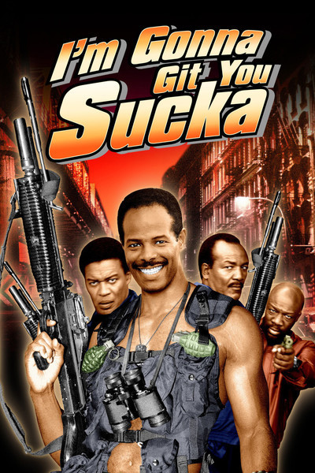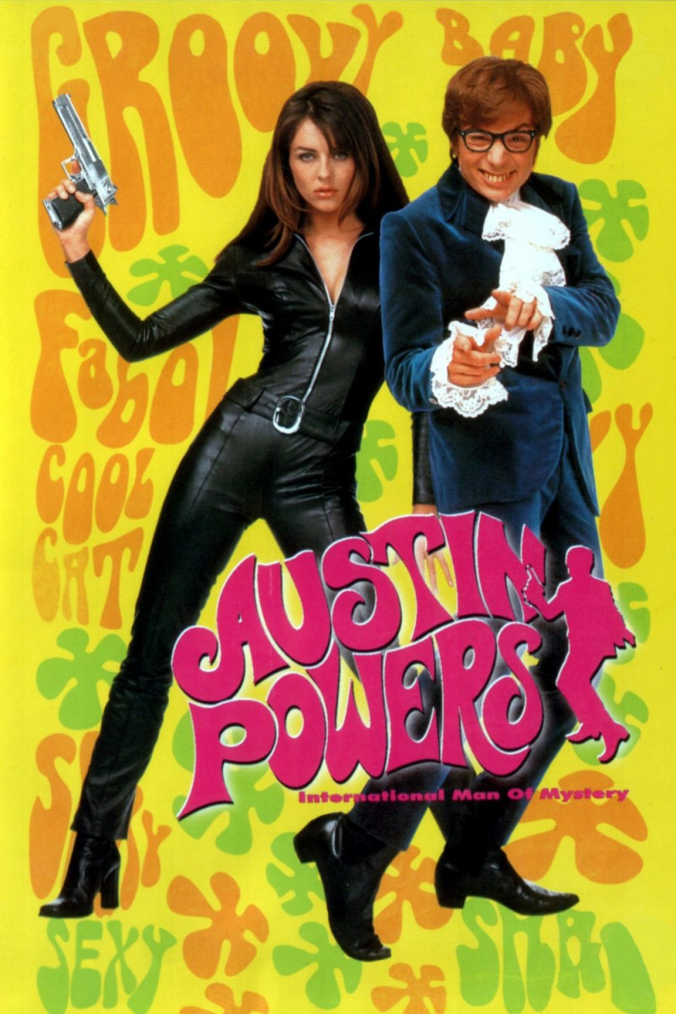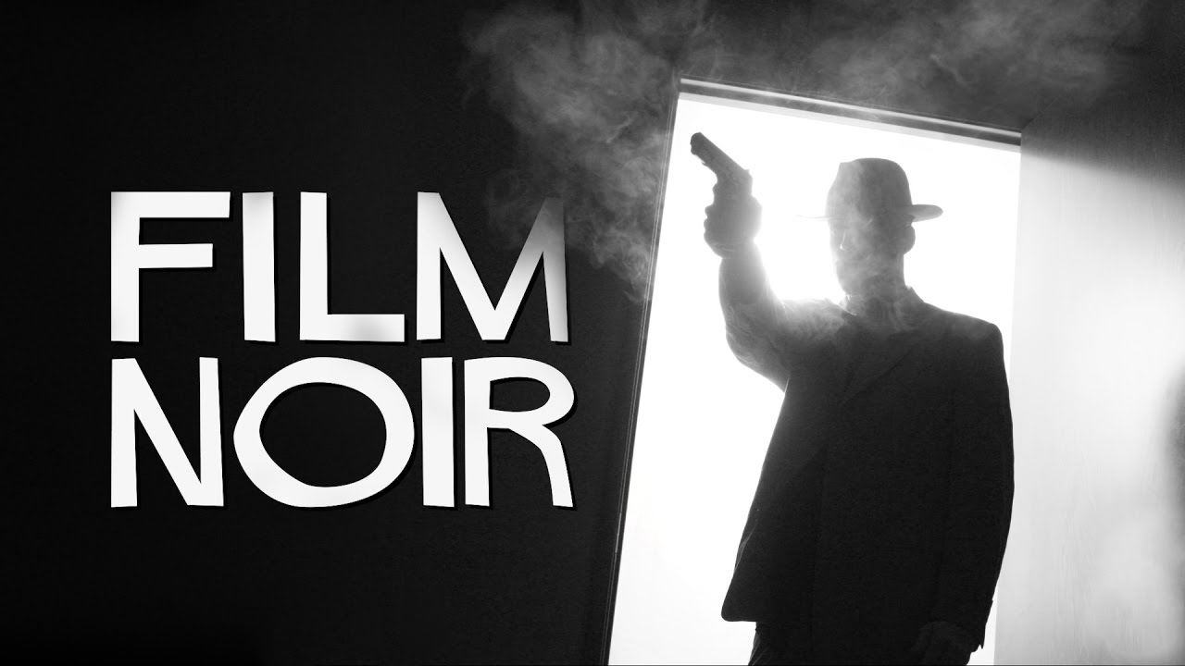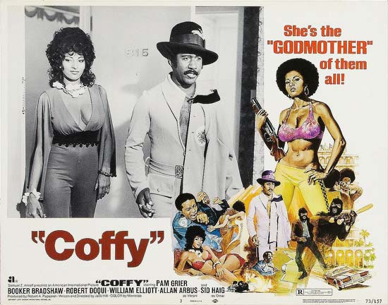The game art style is based on 60’s and 70’s music and cinematography style including films such as “im gonna git you sucka”, “Blacksploitation”, “Austin powers” and also a mix of Film noir style.

This 4 distinct types of movies follow a very distinctive style of their own and make the concept of the game even more intriguing.

60’s and 70’s had a very distinguishable artstyle that